Name: Philopatear Salib
Group Number: 8
Q1. Design/analysis question prompt for each group (can be completed in groups)
Please insert a copy (screenshot and file) of your MATLAB model (or similar) here.
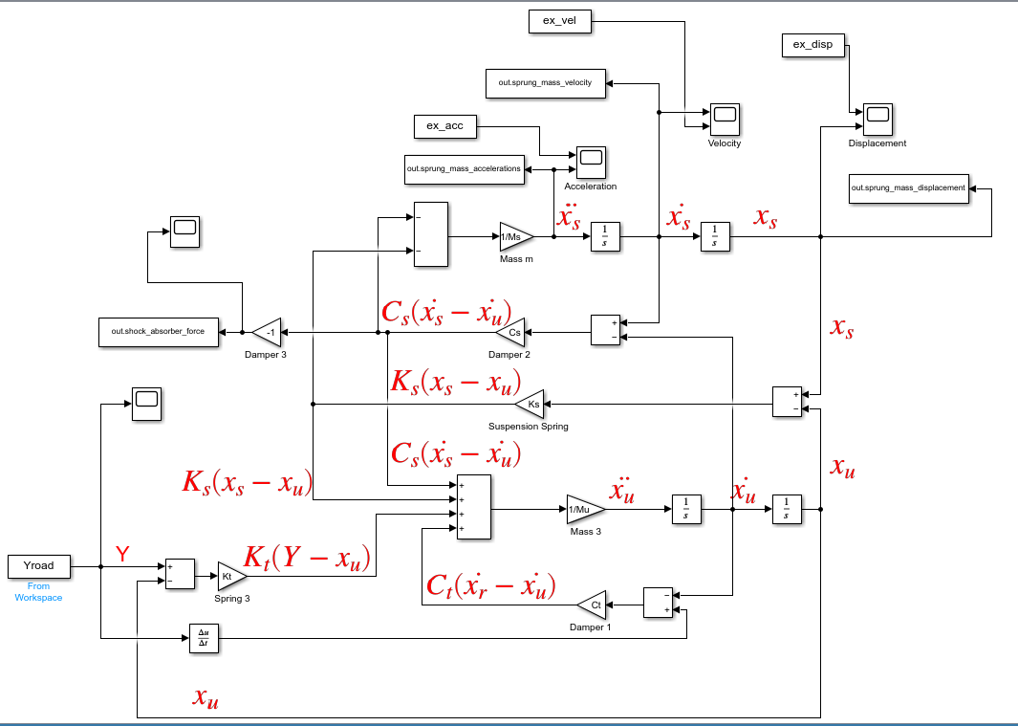
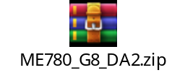
a) How each part of the proposed model relates to the governing equations for a quarter car model.
$$\text{for }C_{s}\left({\dot{x}}_{s}-{\dot{x}}_{u}\right) \text{i}{\text{t}}^{\text{'}}\text{s the equation of the damper reaction on the sprung mass }$$
$$\text{for }C_{t}\left({\dot{x}}_{r}-{\dot{x}}_{u}\right) \text{i}{\text{t}}^{\text{'}}\text{s the equation of the tire reacting as a damper on the un-sprung mass }$$
$$\text{for }K_{s}\left(x_{s}-x_{u}\right) \text{i}{\text{t}}^{\text{'}}\text{s the equation of the reaction of the spring on the sprung mass }$$
$$\text{for }K_{t}\left(Y-x_{u}\right) \text{i}{\text{t}}^{\text{'}}\text{s the equation of the tire reacting as a spring on the un-sprung mass }$$

b) The experimental values for k (N/m) and c (Ns/m) as well as the calibrated (installed) constants.
Parameter | Given/Experimental Values | Utilized/Calibrated Values |  | % Difference
k_{s} [N/m] | 653 | 653 |  | 0
k_{t} [N/m] | 3000 | 3000 |  | 0
c_{s}[Ns/m] | From Video: 100 Ns/m | In Matlab Model: for this here is an equation which fits more the average of Cs | 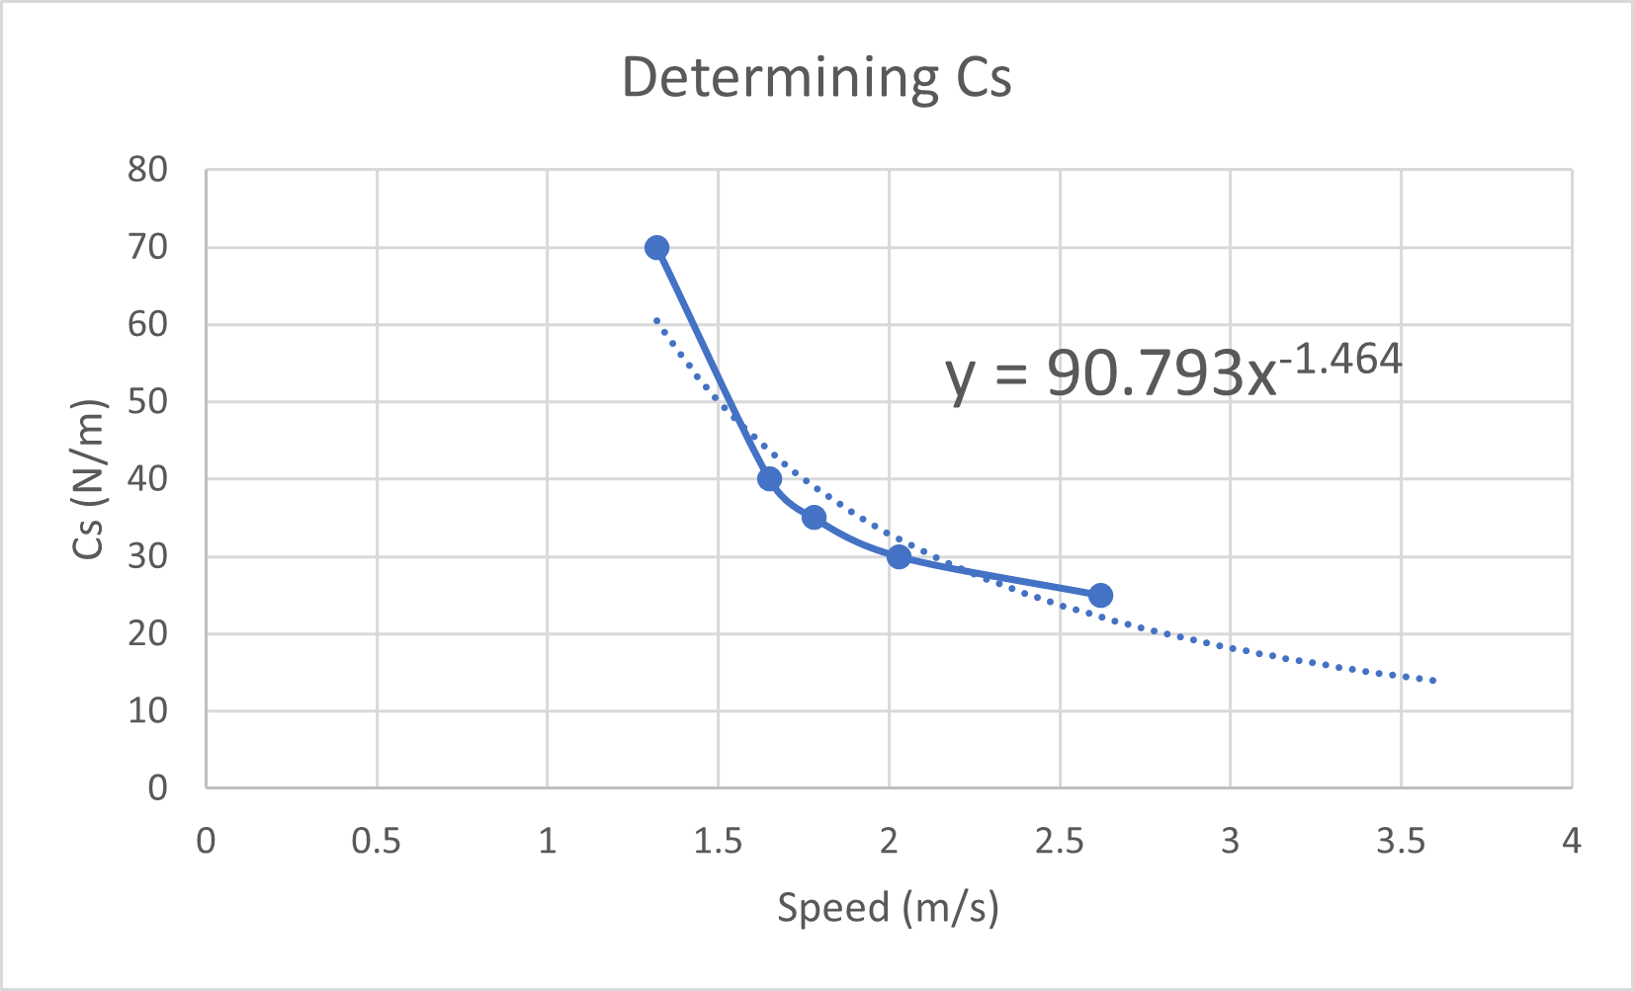 | If we took an average, it will be 40 Ns/m so the difference will be 60%
c_{t} [Ns/m] | 500 | 500 |  | 0

c) Justify, through a free-body diagram (or similar) why your calibrated values might be different from the given values.
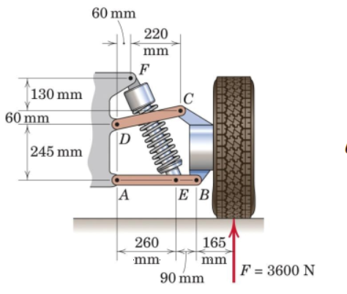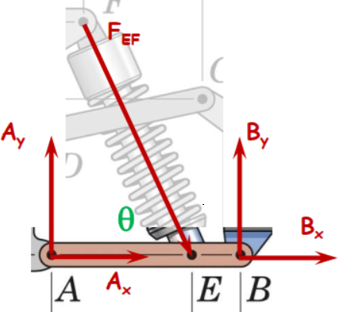
It is because k and c (F_{EF}) are functions of theta, and theta changes with displacement which changes with Velocity.

Q2. Please predict the sprung mass response for the “prediction case” on LEARN
(halversine up (25 mm amplitude) flat (116 mm) haversine down) for the following velocities:
V_{slow} = 1.0 m/sec; V_{med} = 1.72 m/sec; V_{fast} = 3.0 m/sec;
Please note the provided slow motion videos are 1/3 of realtime.
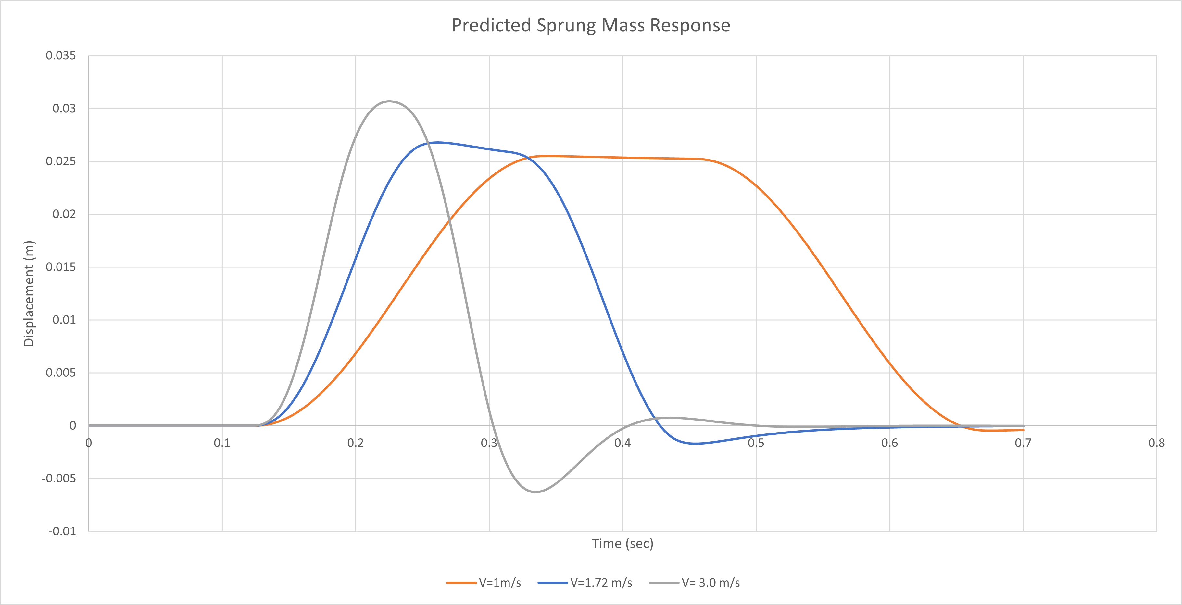

Q3. Using your ¼ car model, calculate the following metrics about the predicted response and compare them to the provided experimental “prediction case” video data responses. Please note that for the experimental cases, some alignment (time/displacement shift) of the response curves may be necessary to obtain accurate calculated results…
Simulation Case | Peak Amplitude x_{s} [mm] | Overshoot [%] | Rise time [ms]  $${Δt}_{10\% 90\%, x_{ss} }$$ | Peak Time [ms] | Peak Sprung Mass Acceleration ${\ddot{x}}_{s}$ [m/sec²]
V_{slow} = 1.00 m/sec | 25.5 | 102.0% | 123.2 | 220 | -2.7
V_{med} = 1.72 m/sec | 26.8 | 107.1% | 68.4 | 140 | 7.1
V_{fast} = 3.00 m/sec | 30.7 | 122.7% | 41.4 | 106 | 16.2
Experimental Case | Peak Amplitude x_{s} [mm] | Overshoot [%] | Rise time [ms]  $${Δt}_{10\% 90\%, x_{ss} }$$ | Peak Time [ms] | Peak Sprung Mass Acceleration ${\ddot{x}}_{s}$ [m/sec²]
1.32 m/sec | 24.9 | 99.5% | 100.0 | 180 | 4.9
1.65 m/sec | 26.5 | 105.9% | 82.0 | 145 | 6.9
1.78 m/sec | 26.0 | 104.0% | 77.0 | 133 | 4.2
2.03 m/sec | 27.4 | 109.5% | 68.0 | 136 | 5.9
2.62 m/sec | 29.5 | 118.0% | 56.0 | 116 | 18.3

Q4. Based on your calculated values in Q3, compare and contrast the predicted sprung mass responses to the experimental test cases. Comment on any inherent limitations in your model or modelling technique.
At a very low speed the peak sprung mass acceleration was different from the experimental cases.
Regarding the equations 14.35 and 14.36 in “Vehicle Dynamics - Theory and Application (Reza N Jazar 2008)”.
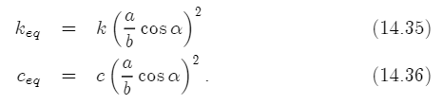
Ks and Cs should both be functions, not constants. we've only modified cs to be a function, so a limitation of our model is that Ks is still a constant, which is wrong.
Please state some comments on what you liked about DA2.
We didn’t get to deep into the forces and the mechanical details.

Please state some comments on what you disliked about DA2.
I think if we could focus more on the control of the active damping it would be better.

